A.S. Chairs Meeting Winter ‘22
- Zoom Link: https://ucsb.zoom.us/j/84894053023?pwd=ZnhPR3VYK1RZRXJVenNKRDhhaGZtZz09
  - Meeting ID: 848 9405 3023
  - Password: 577276
- Presentation: *Themed* AS CHAIRS MEETING WINTER 2022
- RSVP Form: https://forms.gle/rNH5pw1jAcZ6CFt79
- Date: Wednesday 1/12 at 5:00 pm
Meeting minutes:
- 5:00-5:05 pm: Wait for chairs to join meeting
- 5:05-5:15 pm: Greet everyone, introduce ourselves, and talk about CoC
  - Because collaboration within AS is important for bettering the student body as a whole, think of one BCU that you could collaborate with!
  - CoC intro vid
  - The CoC, formerly known as the Committee on Committees, is responsible for the advertisement, recruitment, and promotion of AS. We are also involved in maintaining a positive climate within AS and fostering fruitful relationships and collaboration among AS BCUs.
Transition: now that you’ve learned a little bit about us, we’d like to learn a little bit about you.
- 5:15-5:25 pm: have each individual state their:
  - Name
  - Pronouns
  - Year
  - Major
  - BCU & position
  - Fun fact
- Jenna’s fun fact:
- Liv’s fun fact:

- Questions/comments/concerns
- Groupme link/QR code: https://groupme.com/join_group/84306064/1PT9BE0q
- 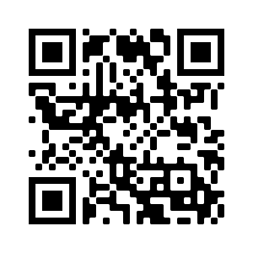

Order

Liv
Introduction (1st slide)
- Hello everyone welcome to the Winter 2022 Chairs Meeting
- Appreciate you giving up your time to spend with us
- We understand that zoom fatigue is real so we will try to be as quick and efficient as possible
Community Guidelines (2nd slide)
- Just as a quick reminder, in order for everyone to effectively do their jobs so they can benefit their board, committee, or organization as well as the student body as a whole, it is essential that we all respect each other in any and every area possible.
- Be mindful of people’s identities, their backgrounds, ideas, and whatever else they choose to bring into this space.
- Also be mindful of your space and how you take up space. Leave room for others so they also feel comfortable and able to take a space and share.
- Kind’ve already touched on this but be mindful of what people choose to bring into this space like past work. Whether you think it was big or small, work done is still work done that ultimately went to benefit some people.
Personal Introductions (3rd slide)
- With that being said, we should probably get to know each other!
- We will all take a turn answering all the prompts. I’ll go first:
- And with that, I’ll pass it to Jenna!

